# Code explanation with screen shots

**1.1-Explanation of the Flask API for Document Summarization**

**(Backend)**

1. Flask Application Setup:

Create flask app instant , defines a single POST endpoint

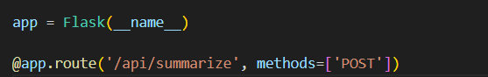

/api/summarize

2. Gemini AI integration :

Configures the Gemini API with a provide key , use the gemini-2.0-flash model for the

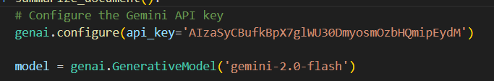

fast summarization

3. Document Processing Flow :

Receives uploaded document files, process different document formats (via Process_document) function from document.py code , then Generates summaries with customable length and detail level.

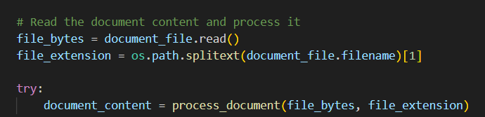

4. Define the prompt for generating the summary

Then try to generate the summary using Gemini

Model ,Execution Runs on all interfaces(0.0.0.) on

Port 5000

**1.2-Flutter API Client for Document Summarization**

For interacting with Flask document summarization API

The main Class (APIClient)contain parameters , summaryLength ,detailLevel,filePath,

**First** creates a multipart request, by setting up the request to /api/summarize endpoint

Then attaches the document file using MultipartFile.fromPath() filnally adds summart parameters as form fields.

**Second Send the request to execute the HTTP call**

**Lasley** Process the response For success (statusCode 200) Reads response stream

, decode JSON to extract the summary field ->**figure 1.2**

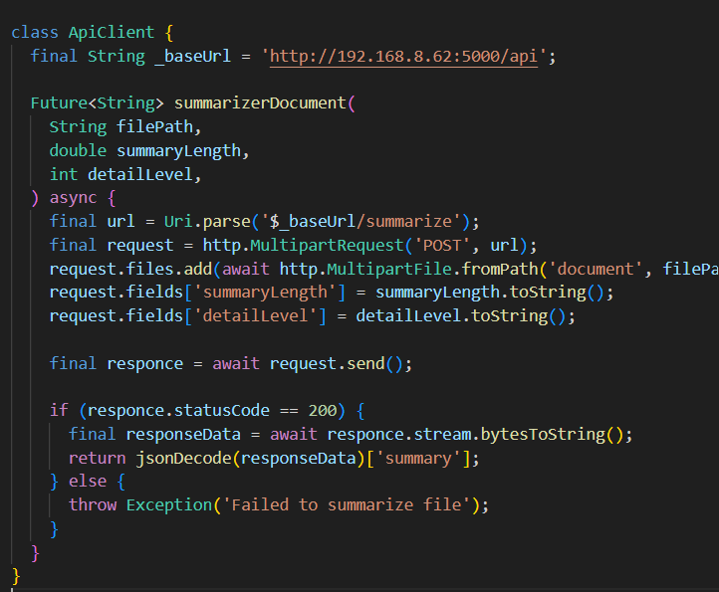figure 1.2

**1.3 : Flutter SummaryService Class Explanation**

This class (SummaryService ) (figure 1.3 )integrate Firebase

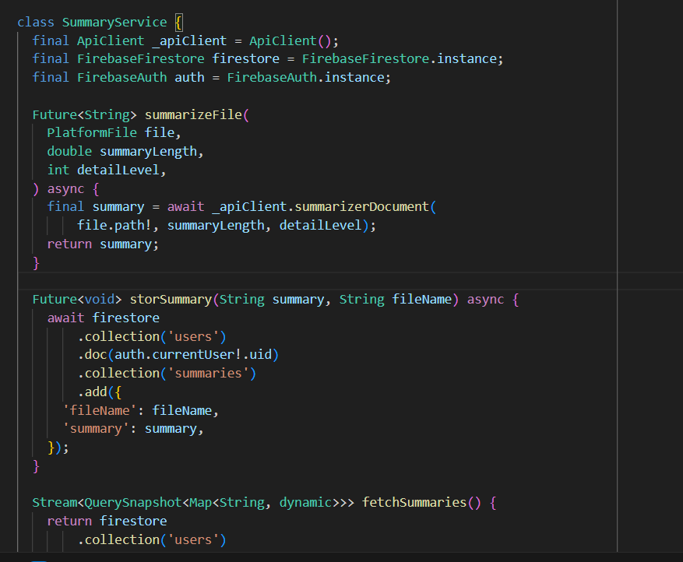figure 1.3

Firestor , Firebase Auth and APiClient to handel

Document summarization and storage

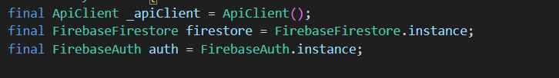

These Lines for initilalization , ApiClient used

To send files to summarization Api,

FirebaseFirestore stores summaries in structures

Way , FirebaseAuth manage user authentication

To store summaries per user

And For the code moethods

-summarizeFile call function suumarizerDocument to send the file to Flask API and returns the generated summary as text (String)

-storSummary fetchSummaries,deleteSummary all these functions deal with firebase DB

**2.Flutter Gemini Chatbot Screen**

This code implementation a chatbot interface using Google’s Gemini Ai with features like text/image messaging , editing , and clipboard copying

For Gimini we use package (flutter_gemini: ^3.0.0)

Need first Initialize Gemini in the main function (figure 2.1)

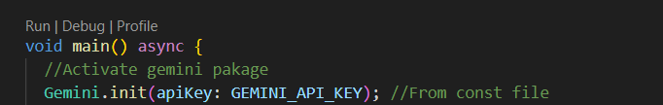figure 2.1

The core Components :

**A.state Management** : uses SattefullWidget to manage

Messages (list of chatMessage) objects, currentUser, gemini(Chat particioants profiles) and Gemini.instace is Ai model handler (figure 2.2)

**B.UI Structure** used DashChat package (figure 2.3)

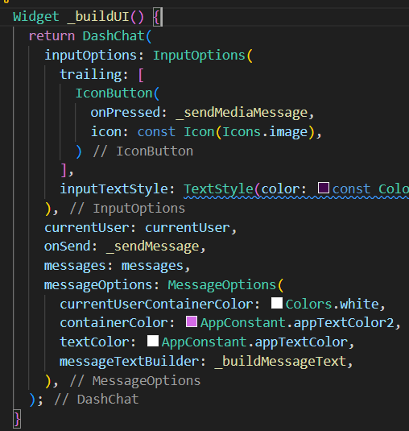figure 2.3

Figure 2.2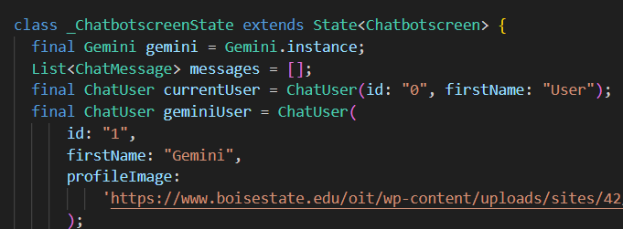

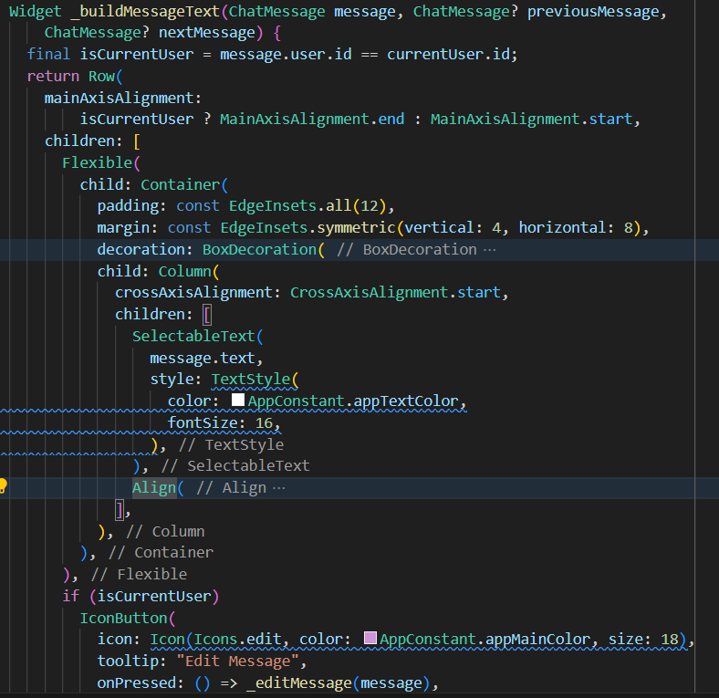figure 2.4

**C.Message** Widget(_buildMessageText) (figure2.4)

This function is for bubble styling copy button, and Edit

Other Methods:

-_**sendMessage**():handel text/image messages by adding user

Messge to messages and if image is attached,read it as Unit8List

And for strean gemini’s respomce updage UI in realtime and

Appends response to exusting messages

-_**sendMediaMEssage**():this method for opening camera/gallery

Via package (ImagePicker) and sends the image to Gemini with a default prompt :”Describe this picture?”

**3-Flutter Translation API**

This code implements a language translation interface using Googles Translation

API(**translator package**), the code supported 6 languages(figure 3.1)

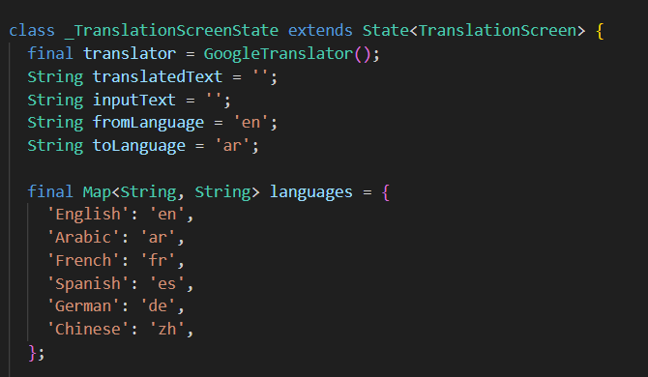figure 3.1

The core function is **translateText**():

Figure 3.2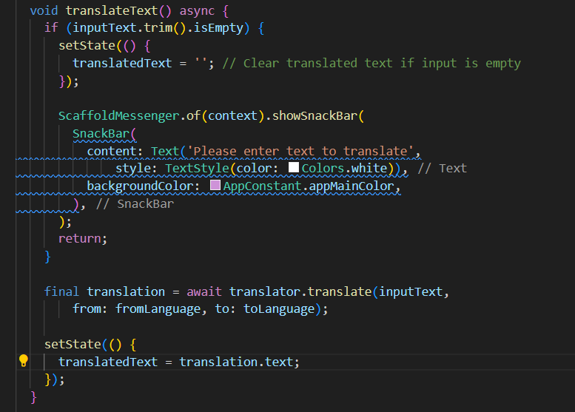



This function checks for empty input ->shows snakbar if emply

Call Google Translator , updates translatedText with result

Figure(3.2)

**4-Flutter Notes screen**

figure 4.1

**T**his class contain NoteModel and

Textcontroller , figure 4.1

For NoteModel:

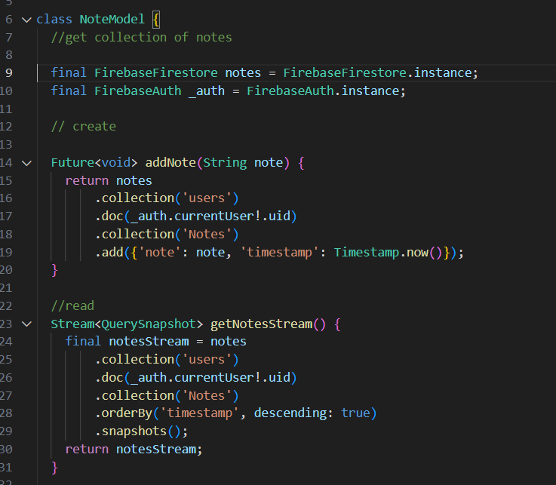figure 4.2

This class use FirebaseFirestore to save , update,

Delete notes , and firebaseAuth for each current user

This class have multiple methods as shown in figure4.2

And for _NoteScreenState used the NoteModel

For controlling UI and how the user deals with nots

(Figure 4.3)

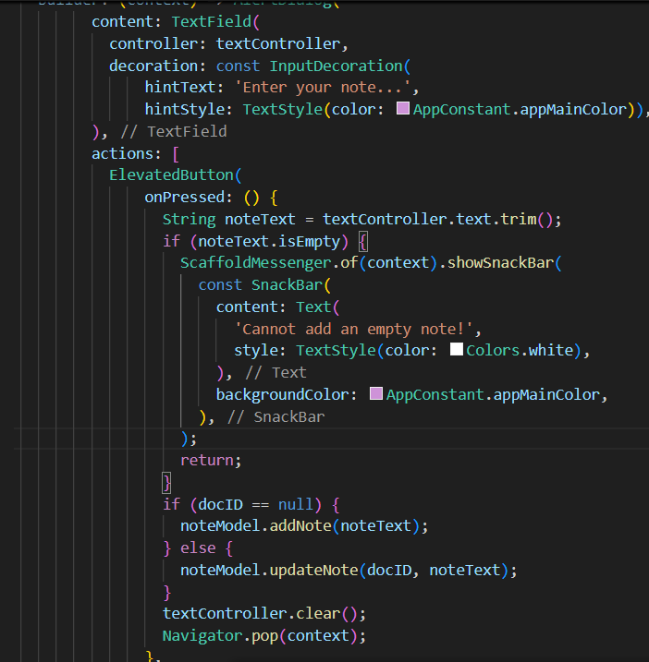figure 4.3



**5-Flutter TO-DO-List screen**



Figure5.1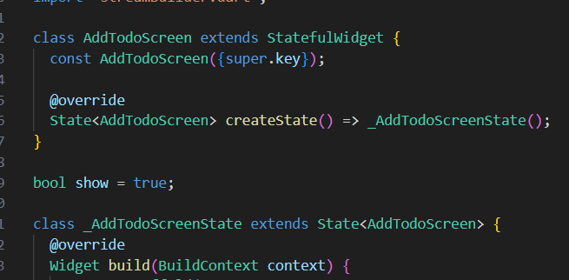

**AddTodoScreen** class is the main UI class

That contain all other components lo let the user

Making to do lists ,

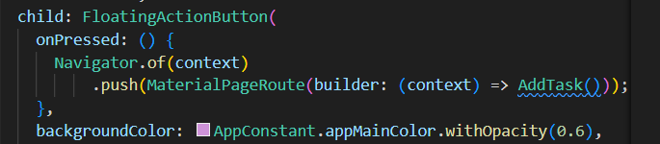figure 5.2

Figure 5.2 , button to let the user add Task

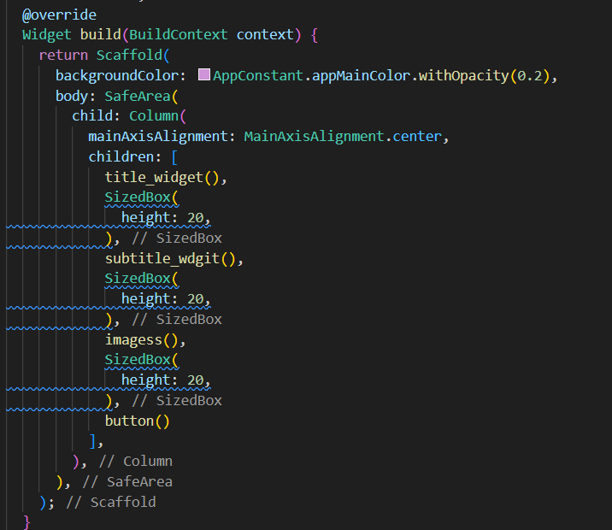figure 5.3

this component as shown figure5.3

let the user enter task title ,task subtitle,images for

one task then upload this task to firebasefirestor

if the user click add and Cansel if the user want to

other functions for retreveing tasks , tell if the task

is done or not , display all task details and edit them when the user

click on any of the tasks -figure 5.4-

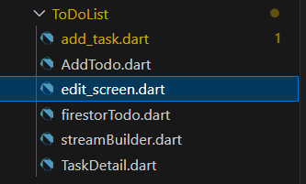figure 5.4

**6-Flutter Add file Screen**